TECHNICAL IMPLEMENTATION REPORT
Mafikeng Game Reserve Lodges Network
CMPG325 Computer Networks Project | Final Technical Documentation and Evidence

Project ID | CMPG325-2026-061
Client ID | CLI-061
Organisation | Mafikeng Game Reserve Lodges (Mahikeng)
Technical challenge | VLAN trunking (IEEE 802.1Q across switches)
Addressing block | 10.28.0.0/16
Submission date | 16 October 2026

1. Executive Overview
This report documents the submitted Cisco Packet Tracer network for Mafikeng Game Reserve Lodges. The design focuses on separating departments with VLANs, carrying VLAN traffic between switches using 802.1Q trunk links, routing between VLANs through a multilayer core switch, and providing primary and backup paths toward the simulated Internet. The accompanying evidence images are taken from the submitted Milestone 2 package.

2. Project Objectives
- Create a segmented network using the configured departmental VLANs for Management, Finance, Sales, HR/Operations (confirm the final department label), and Guest Services.
- Configure VLANs on the core and access switches.
- Configure trunk links to carry the required VLANs between switches using IEEE 802.1Q.
- Use the core multilayer switch to provide inter-VLAN routing through switched virtual interfaces (SVIs).
- Configure routing toward two simulated ISP paths, with a backup path intended to improve availability.
- Verify the configuration with command output and connectivity testing.

3. Network Design
The submitted topology contains a core switch, two access switches, two internal routers (R1 and R2), two ISP-side routers (ISP1 and ISP2), internal end devices, and two simulated Internet servers. The core and access switches form the internal switched network. The two router/ISP branches represent the primary and alternate external paths.
Department VLAN and IPv4 addressing plan:
VLAN | Department | Subnet | Default gateway
10 | Management | 10.28.10.0/24 | 10.28.10.1
20 | Finance | 10.28.20.0/24 | 10.28.20.1
30 | Sales (observed) | 10.28.30.0/24 | 10.28.30.1
40 | HR / VLAN0040 (name inconsistent) | 10.28.40.0/24 | 10.28.40.1
50 | Guest_Services | 10.28.50.0/24 | 10.28.50.1
99 | Network_Management | 10.28.99.0/24 | 10.28.99.1
The gateway addresses for VLANs 10, 20, 30, 40, 50 and 99 were verified from the CORE-SW command output. VLAN naming is not fully consistent across the switches: VLAN 30 appears as “Sales” and VLAN 40 appears as “VLAN0040” on the core/ACCESS-SW1 but “HR” on ACCESS-SW2. Confirm the official department labels against the project brief and standardise the names before final submission. The IP addresses below are verified as SVI gateway addresses; end-device addressing was not independently inspected in this review.

4. Implementation Summary

4.1 VLAN configuration
VLANs are defined on the core and access switches so that end devices can be grouped by department.

4.2 Trunk links
Trunk interfaces are used between the core and access switches. The trunk evidence screenshots show the switch interface status and trunk-related output.

4.3 Inter-VLAN routing
The multilayer core switch uses SVIs as department gateways and has routing enabled to support communication between VLANs, subject to configured access and routing policies.

4.4 WAN and ISP connectivity
R1 and R2 connect toward separate ISP branches. The ISP-side networks connect to separate simulated Internet servers.

4.5 Finance capacity change
The project brief includes a change request for eight additional staff in one department. The Finance segment should therefore be checked to ensure it accommodates the additional eight endpoints without redesigning the VLAN structure.

5. Verification and Testing
The supplied ZIP includes screenshots for the topology, VLANs, trunk interfaces, SVIs, routing tables and a ping test. Additional live CLI output was reviewed during this session. The user reports that connectivity is working. The command output verifies trunking, active VLANs, SVI state and the core routing table. The precise source/destination and results of the reported live connectivity tests were not captured as text in this review, and a separate primary-link failure/failover test has not been evidenced here.
Test area | Evidence supplied | What it demonstrates
Overall topology | Full Topology.png | Physical/logical device layout and connections.
VLAN membership | Core Switch-VLAN.png; Access switch-VLAN .png; Access switch 2-VLAN.png | VLAN configuration output on the switches.
Trunk interfaces | Core Switch-Interface trunk.png; Access switch-Interface trunk.png; Access switch 2-interface trunk.png | Trunk status and trunk-related interface output.
SVIs | core Switch-SVI.png | Core switch virtual interface and gateway configuration output.
Routing | Core Switch-Routing.png; R1-Routing.png; R2-Routing.png | Routing table/output from the core and internal routers.
Connectivity | PING test.png | Ping test evidence for the specific endpoints shown; live connectivity was reported as working, but record source, destination and outcome in the final demonstration.

5.1 Live CLI verification recorded during review
The following results were copied from the CLI during the final review. They supplement the screenshots in Appendix A.
Trunk verification — CORE-SW and ACCESS-SW1: Fa0/1 and Fa0/2 report Status “trunking” and Encapsulation “802.1q”. VLANs 1, 10, 20, 30, 40, 50 and 99 appear as allowed/active and in spanning-tree forwarding state. ACCESS-SW2 Fa0/1 reports the same trunk state and VLAN forwarding list.
Core SVI verification: Vlan10 10.28.10.1, Vlan20 10.28.20.1, Vlan30 10.28.30.1, Vlan40 10.28.40.1, Vlan50 10.28.50.1 and Vlan99 10.28.99.1 all report Status up / Protocol up. GigabitEthernet0/1 (10.28.254.2) and GigabitEthernet0/2 (10.28.254.10) also report up/up.
Core routing table: connected routes are present for 10.28.10.0/24, 10.28.20.0/24, 10.28.30.0/24, 10.28.40.0/24, 10.28.50.0/24, 10.28.99.0/24, 10.28.254.0/30 and 10.28.254.8/30. Static routes are shown for 10.28.254.16/30 via 10.28.254.9 and 10.28.254.20/30 via 10.28.254.1. The default route is 0.0.0.0/0 via 10.28.254.1.
Interpretation: these outputs support successful trunk operation and Layer 3 gateway/routing configuration on the core. They do not independently prove every end-device path, Internet-server reachability, or failover after a link failure.

5.2 Configuration consistency and evidence gaps
VLAN naming differs across the supplied switch outputs: VLAN 30 is named “Sales”; VLAN 40 is “VLAN0040” on the core and ACCESS-SW1 but “HR” on ACCESS-SW2; VLAN 50 is “Guest_Services”; VLAN 99 is “Network_Management”. The numerical VLAN IDs and active/forwarding state are consistent in the outputs, but labels should be standardised to the official client requirements.
The core trunk output allows VLANs 1–1005. The required VLANs are active and forwarding. If the project requires a restricted allowed-VLAN list, configure it only after confirming the intended design and then recapture the trunk evidence.
The supplied ZIP has 12 evidence screenshots and the Packet Tracer file. The rubric also requires a GitHub portfolio and an individual 15–20 minute video, which are separate deliverables and are not present in this ZIP.

6. Conclusion
The submitted package contains the Packet Tracer topology and evidence screenshots for switching, VLANs, 802.1Q trunking, SVIs, routing and connectivity testing. The live command output confirms that the core and access-switch trunks are operational and that the core SVIs are up/up. The core routing table includes connected departmental networks and a default route via 10.28.254.1. Before claiming full resilience, capture a separate failover test showing that connectivity remains available after the primary path is disabled. Also confirm the department names and the Finance capacity change against the project brief.

Appendix A — Submitted Evidence Screenshots
Figure A1. Full Packet Tracer topology.
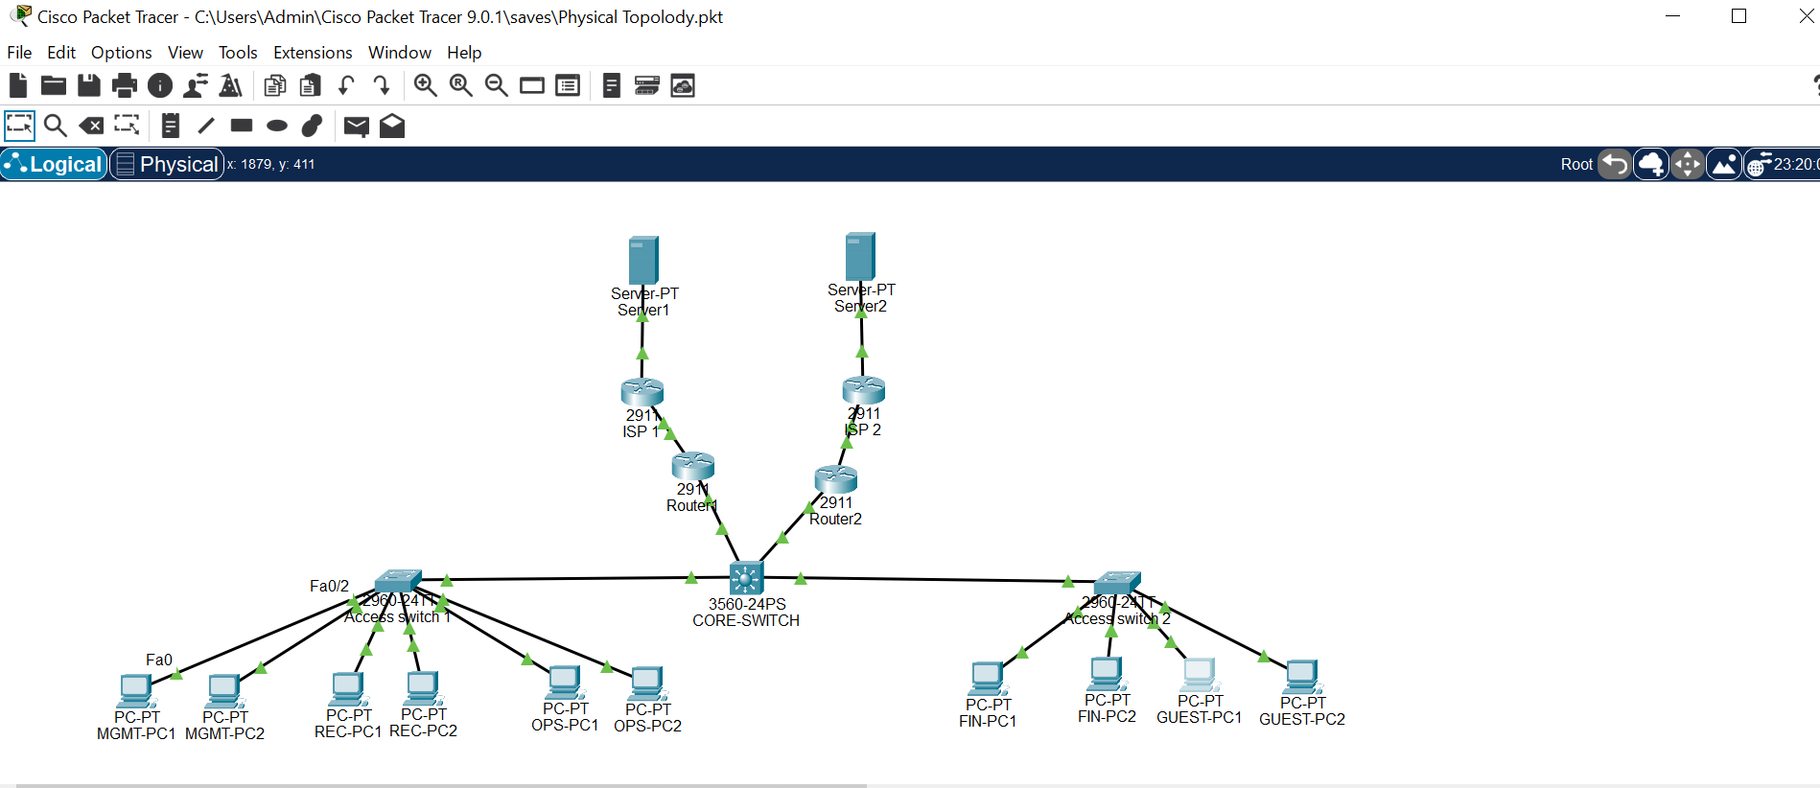
Figure A2. Core switch VLAN configuration evidence.
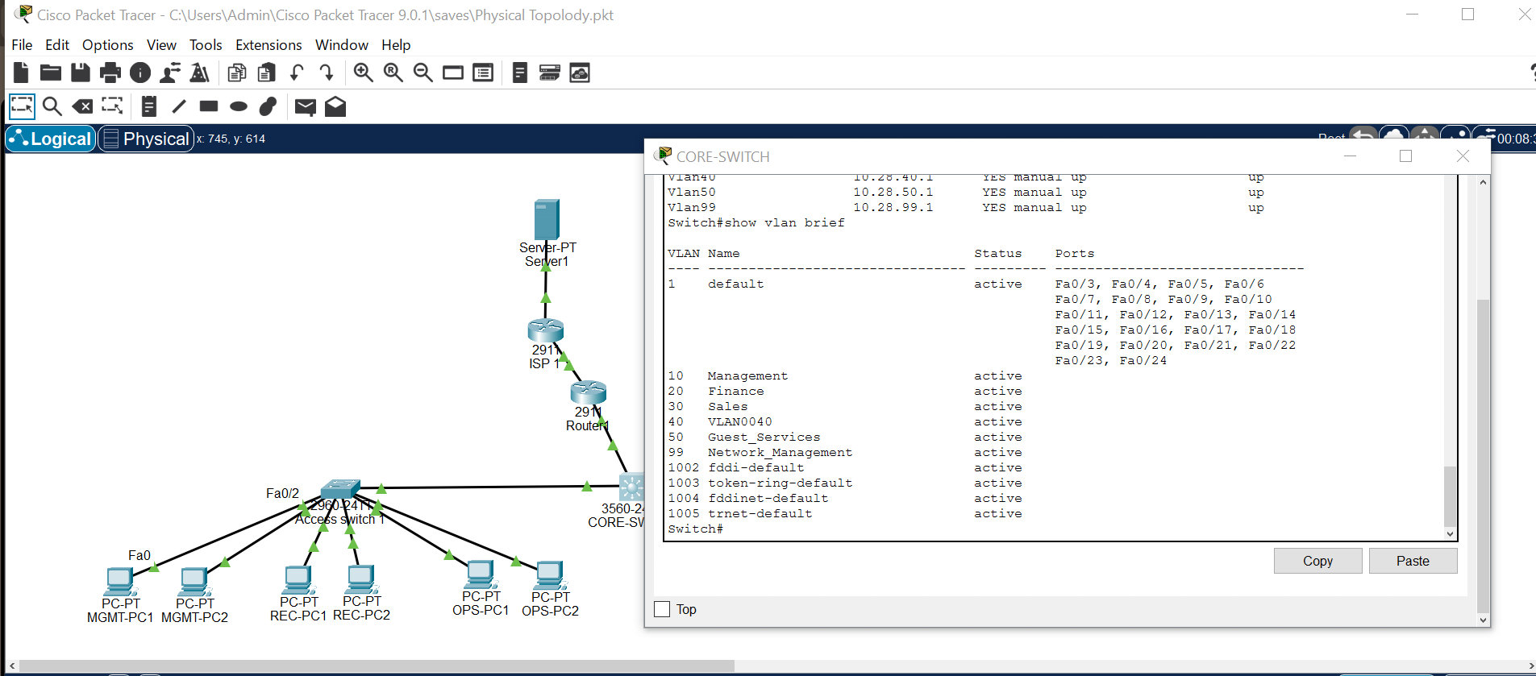
Figure A3. Access switch 1 VLAN configuration evidence.
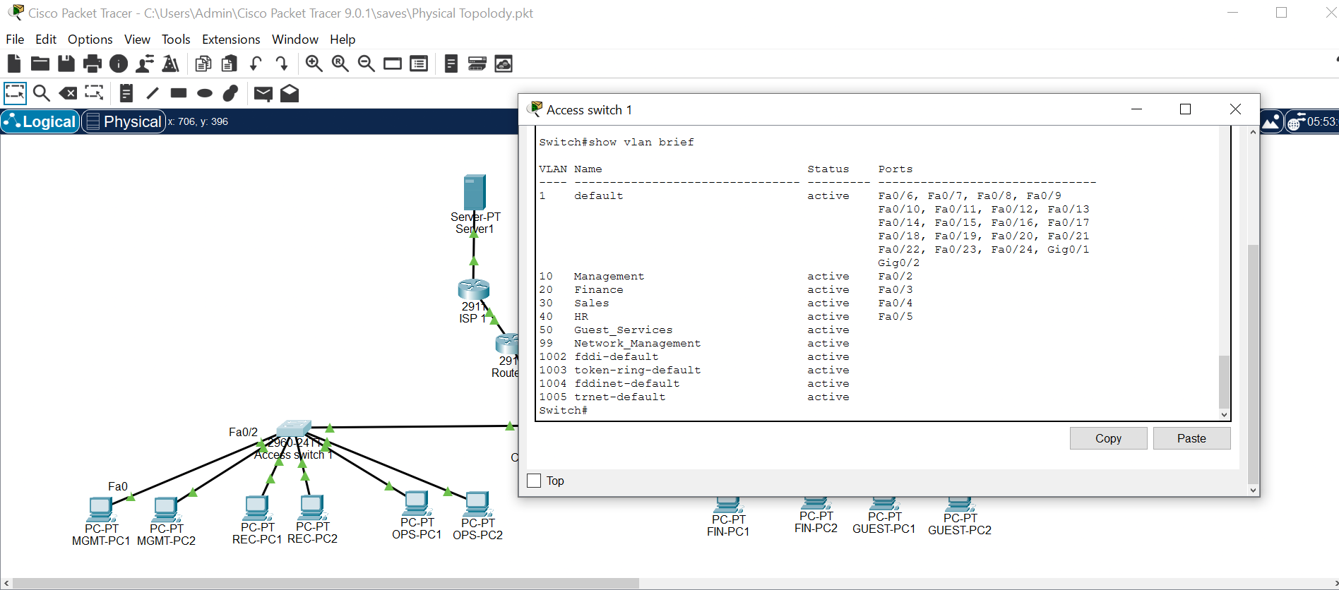
Figure A4. Access switch 2 VLAN configuration evidence.
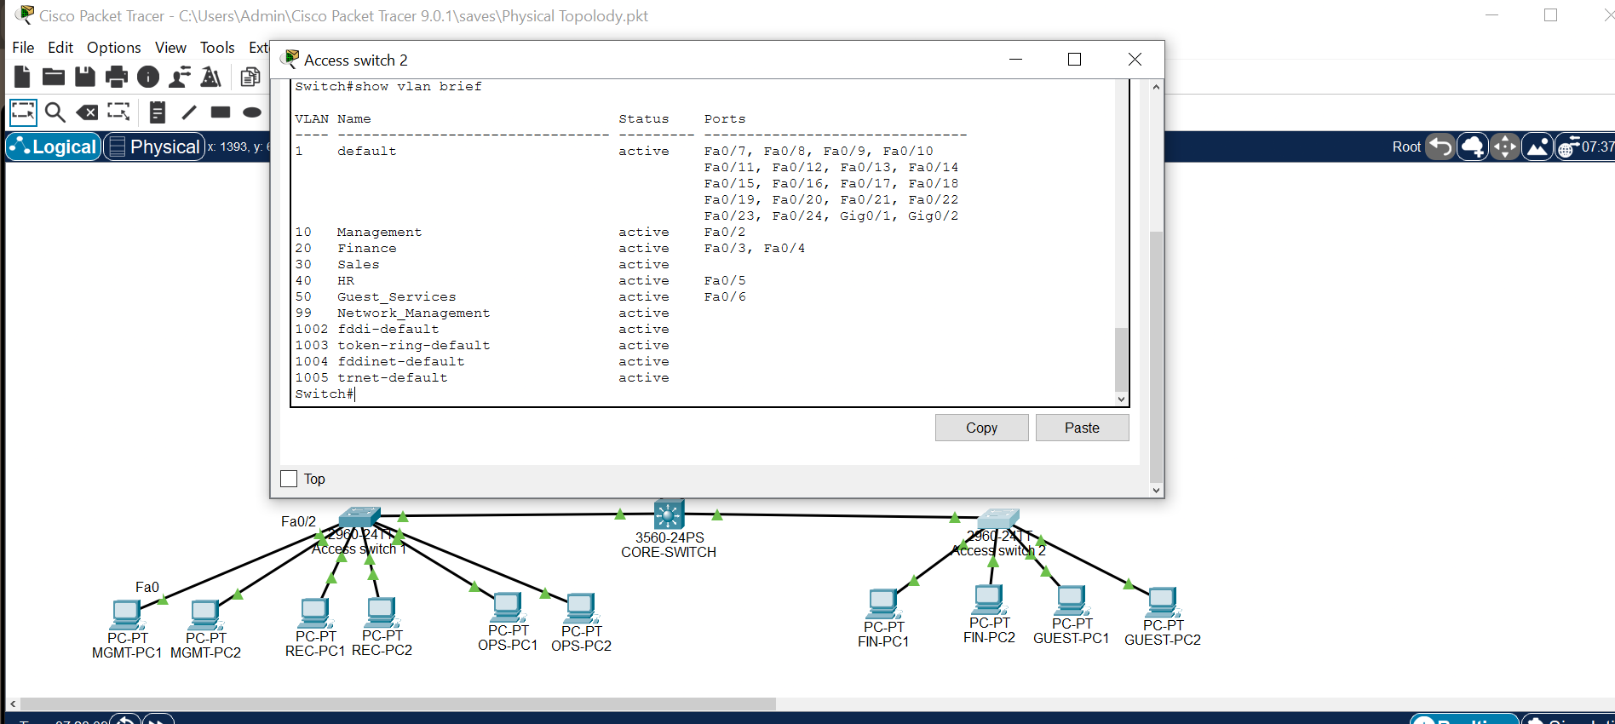
Figure A5. Core switch trunk interface evidence.
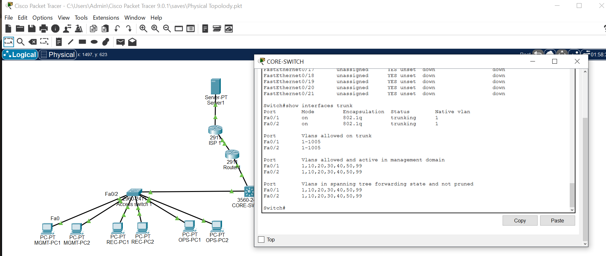
Figure A6. Access switch 1 trunk interface evidence.
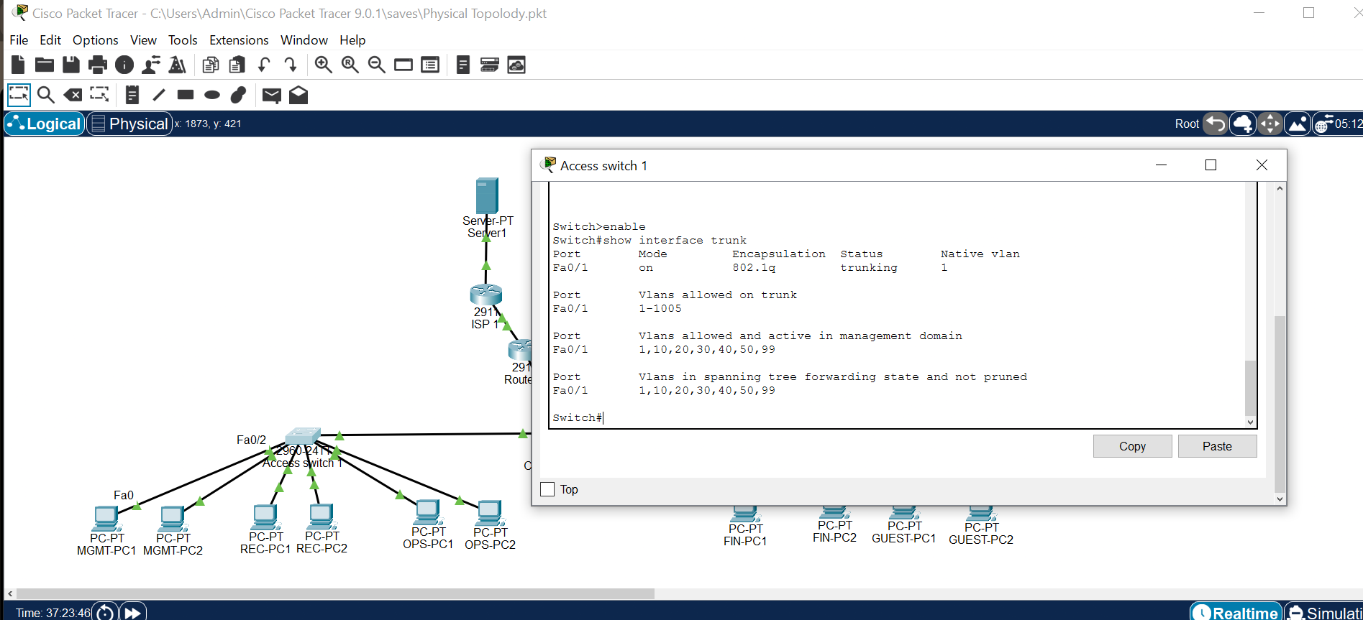
Figure A7. Access switch 2 trunk interface evidence.
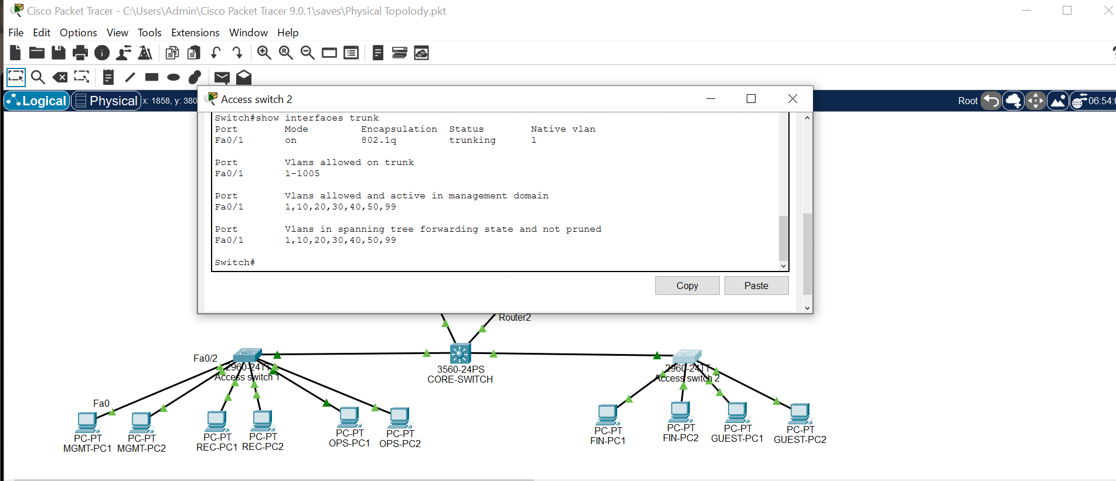
Figure A8. Core switch SVI evidence.
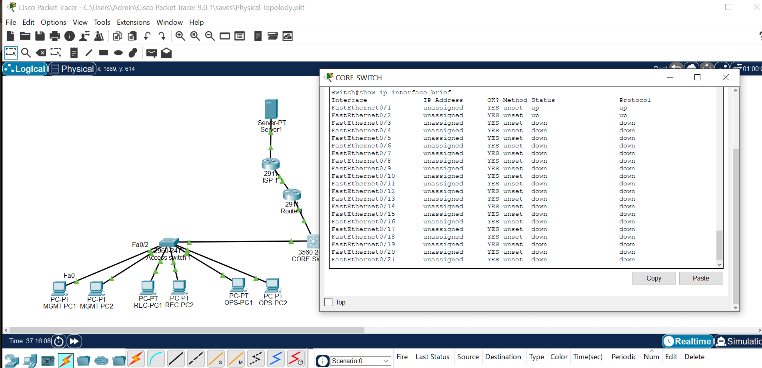
Figure A9. Core switch routing evidence.
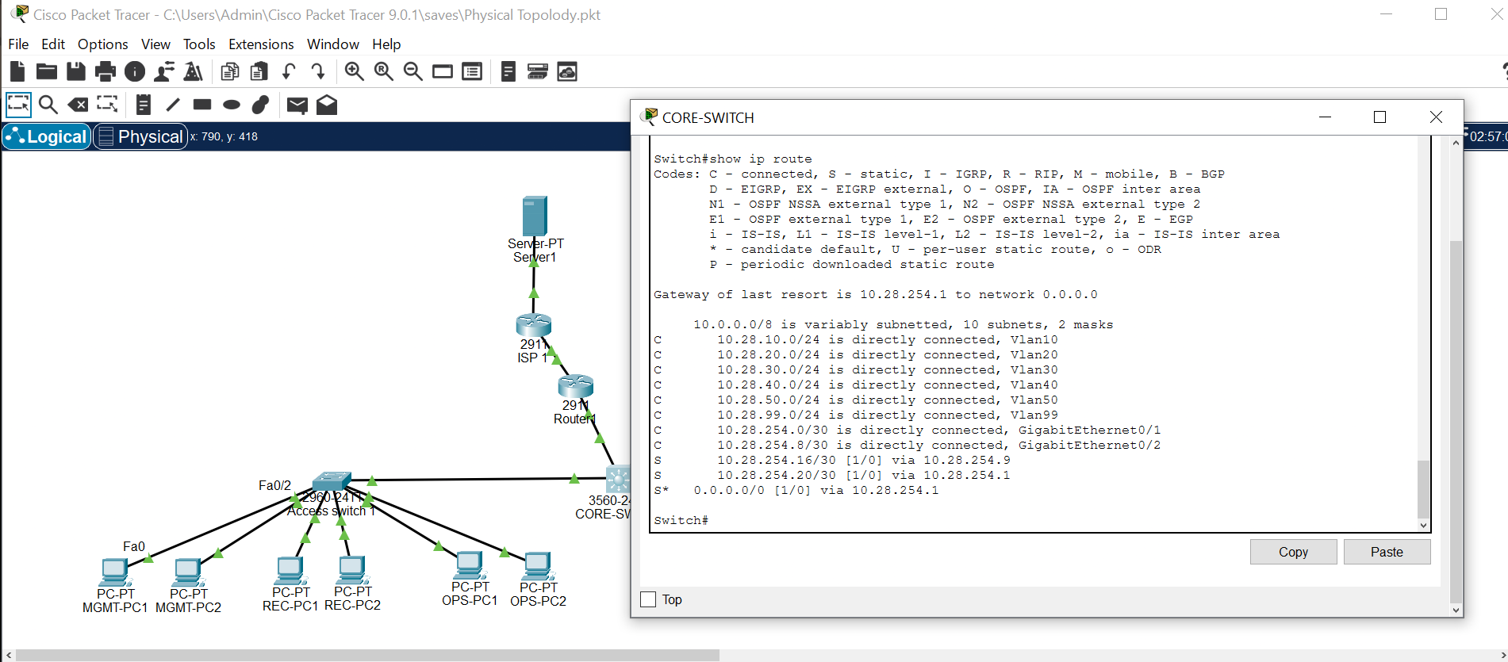
Figure A10. R1 routing evidence.
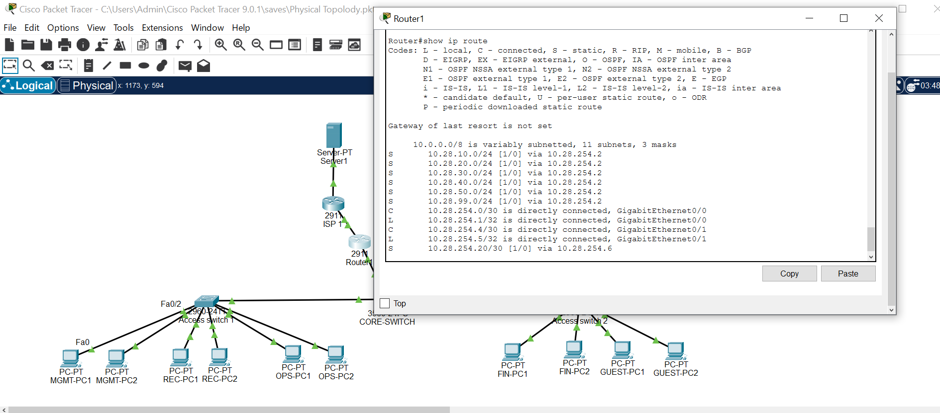
Figure A11. R2 routing evidence.
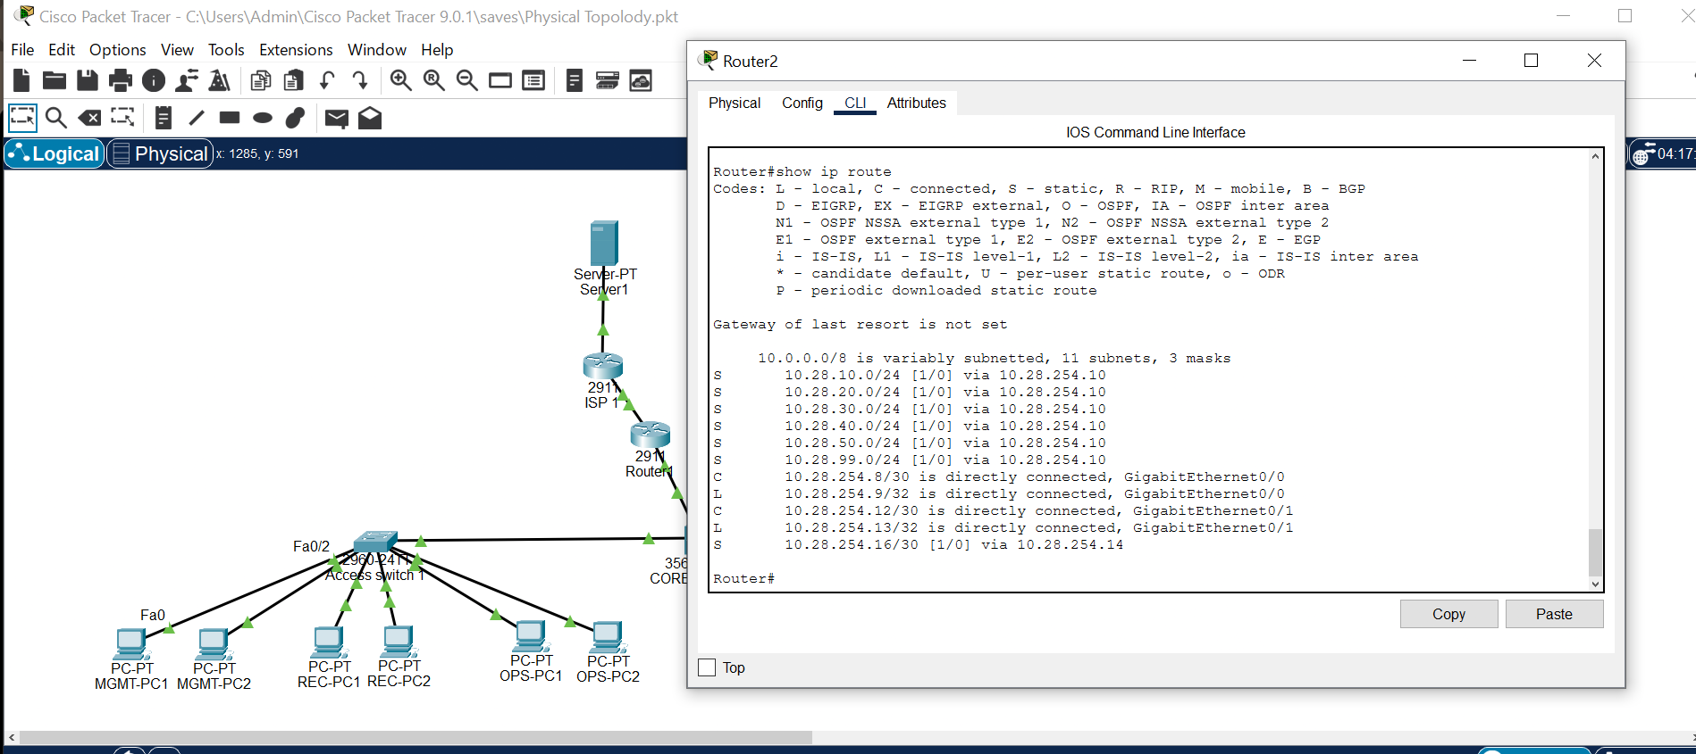
Figure A12. Connectivity/ping test evidence.
